Integrated Solid Waste Management Kutaisi
Solid Waste Management Company of Georgia

German Financial Cooperation with Georgia
BMZ No.: 202061364

“Improving municipal waste services in the project region”
Recommendations towards the optimization of future procurements of technical equipment based on the findings made during field investigations and talks in project municipalities in 2018 and 2019

J. Reichenbach / INTECUS GmbH
Submitted by PEM GmbH
in association with

Table of Contents
1 rationale 3
2 Equipment Spectrum 4
2.1 Containers 4
2.2 Collection Trucks 4
3 adequacy of Equipment 5
4 Hardware Deficits 5
4.1 Containers 5
4.2 Collection trucks 7
5 Recommendations 9

rationale
Starting from September 2018 till the end of 2019, the AMC represented by the international SWM expert and local counterpart conducted a series of talks and field investigations involving municipal administrations and waste service staff with the focus being laid on performance monitoring and the potentials to improve the provision of waste services in the Racha-Lechkhumi/Kvemo Svaneti region.
Among others, the waste collection tours in various settlement structures of the region were escorted and analysed together with the utilisation patterns, technical state and performance of corresponding equipment such as trucks and containers.
The observations and findings made this way were shared and discussed in trainings and further regular meetings held with municipal staff from the entire project region. With that additional information and evidence on the individual issues could be obtained also from places not directly incorporated in the studies on the ground.
This process led to a consolidated picture about the efficiency and shortcomings of the waste collection equipment currently available in the municipalities and thus a pool of information that should be thoroughly examined and taken into consideration for future procurement processes and the formulation of specifications and criteria adopted for this.
By way of this document a summary of the most critical findings in relation to suboptimal equipment design and performance in the project area is provided and complemented by recommendations for future procurement rounds of equipment.

Equipment Spectrum

Containers
In the project region, like in the whole of Georgia, waste containers of various designs, age and size are employed for the collection of mixed municipal solid waste. Wheeled-mobile containers in the volume range of 0.6-1.1 cbm. make up the majority, whereas the very old style stationary dumpsters (‘waste bunker’) are increasingly being decommissioned and removed.
The dominance of 1.1.cbm wheeled-mobile containers began with a bulk procurement of corresponding containers (12,053 units in total [1]) via state funds and their distribution to the municipalities during the years 2017/18. Round-cover metal containers and flat lid plastic containers both were part of these procurements. Included in the number of containers purchased in the year 2017 were also 10,000 plastic containers with divided flat lid cover.
The project region received 2,588 new container units in total from this procurement [1]. Each municipality usually was handed over the amount of 100-150 container units, only Kutaisi got double that number which increased the total stock here to about 1,700 containers till 2019. The city since then has purchased nearly a hundred additional units (240 ltr/1.1. cbm) under a tender procedure launched by herself for a waste separation pilot.
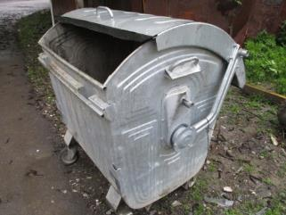 | 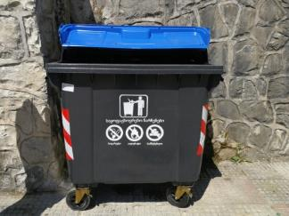 | 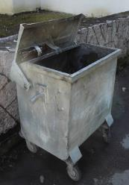
1.1 round-cover metal container  (1.1MetC) | 1.1 plastic container with divided flat lid cover  (1.1PlaC) | 0.6 flat lid metal container  (0.6MetC)
as the three dominant waste container types in the project region

Collection Trucks
As part of the supply of additional SWM equipment, new collection trucks were also handed to the municipalities in 2017. The larger number of municipalities received two such trucks, one rear-end loading compaction truck with a gross body-volume of 13m³ and one four wheel drive rear-end loading compaction truck with a gross body-volume of 7m³, both models based on Mercedes chassis. Only few municipalities with larger urban centers received more vehicles, usually this comprised one additional truck with a gross body collection volume of 7m³, Kutaisi got two 13m³ and one 20 m³ model [1].
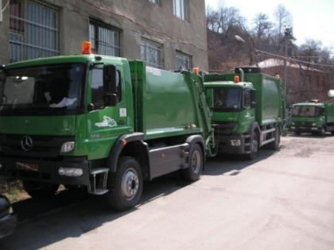
Mercedes compaction trucks of different size (front: with 7m³, back: with 13m³ gross collection volume) used since 2017 in the municipalities of the project region

adequacy of Equipment
Neither from tour escort analyses nor the observations made during different seasons in the field can be derived indications for an acute shortage of waste containers/waste container capacities in the well-accessible areas of the municipalities. This, however, is a generalized conclusion which does not exclude individual cases where a higher density of container sites or supply with additional containers might still be desirable.
Occasionally comments are made by residents and municipal representatives concerning the number of containers. Residents basically do this out of the perspective of further increased convenience (shorter walking distance to the containers), not out of the perspective of better waste collection. Municipal officials formulate this in part also with regard to further development and planning commitments that exist in waste management and for the infrastructure in the municipality.
A look at the efficiency of collection as well as the overall cleanliness of the landscape (as established during the tour escorts) do not reveal any significant lack of containers or container capacities or an urgency for increasing the container stock at present in municipalities, however. Theoretical calculations and numeric benchmarks support this analysis.
Fairly consistent are also municipal officials in their statements that thanks to the available equipment all areas for which waste collection had been conceivable and considered already before are meanwhile supplied such service. Indeed can be said that municipalities, as a general rule, have chosen container sites under the current realities very practically and are able to ensure the collection of the mixed waste reliably with the adopted collection regimes and equipment at hand.
In contrast, the need to optimize processes and to have certain components of the equipment so far used improved or changed in future appears to be much more pressing.
Indications towards the need to optimize processes including container distribution patterns have been found in facts such as
- containers show quite some capacity reserves (or rather low filling levels) at the moment of emptying,
- collection of waste from remote settlements shows extremely unfavorable time and cost parameters.
Details and recommendations concerning these issues are subject of a separate report.
Focal points of this document shall be the deficits and improvement potentials related to waste collection hardware/equipment.
The reasons to claim improvements in this field are being delivered by observations of the following sort:
- container losses in considerable number due to damages,
- poor performance parameters during collection as a result of suboptimal hardware design,
- considerable potential for accidents and dangers to human health arising from vehicle configurations, lacking components and the kind of containers used in specific environments.

Hardware Deficits

Containers
Container types:
A significant portion of the most recent container supply to municipalities involved 1.1 cbm. plastic container with divided flat lid cover. Plastic type containers suit current conditions in the remoter and more rural type areas less than metal containers. A major concern is durability.
- The containers in general are exposed to high mechanical stress in these areas. This basically has to do with conditions found at the container sites. Many of the containers stay on an uneven, often soft or stony underground. Hauling and fixing the containers to the truck for emptying is particularly difficult on such rutted terrain and consumes a huge exertion of physical force. Plastic containers do not have the same stiffness/sturdiness that metal containers show. Hence, torsions of the body or on components can be noted while these containers are being hauled, pushed and attached to the truck in these conditions under the use of immense physical force. Container filling levels at the moment of collection were found to be rather low in the villages at present. That situation is supposed to change when collection processes are optimized. The heavier containers become, the more force must be exerted on them during collection then. Not only the risk of containers damages increases but also the physical stress for collection staff.
Municipalities recognise this risk and expressed serious concerns that such damages are inevitably a consequence the longer containers are in use and the more extreme situations are encountered (e.g. high container loads, longer periods of rain and frost). Especially low temperature phases will further raise the fragility of the plastic material. The region hasn’t experienced such phases since the introduction of the new containers yet but these do normally occur here.
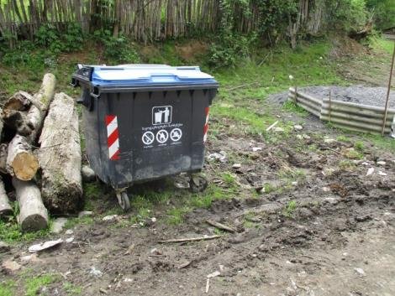
Typical conditions at container sites in the more rural structures.
- What also occur frequently in the region are strong wind blows. The municipalities report that plastic containers blown away and/or overturned by the wind happen quite frequently. They also referred container losses due to serious damages caused in this context. Given their high net weight it can be assumed that the likeliness of the same occurring to metal containers is lower.

- Repairability of the different container types comes next here as a concern. Components broken apart (e.g. wheels, lids or handles) cannot easily be repaired on plastic containers as how they can on metal containers (e.g. by welding). Municipalities and/or the waste service companies usually have a yard and staff for repairing equipment that is slightly damaged. Whilst for the metal containers there is a large potential to undertake repairs with a limited spectrum of tools and means this is not so the case for plastic containers. To demount some spare parts is all the municipalities can do at the moment with broken plastic containers.

- Unlike the metal containers, the plastic containers do not have an automatic mechanism for closing the lid. A permanent exposure of the container content to the weather is taking place whenever users or collection crews leave the lid of plastic containers open or the wind opens them. Rain, snow and animals can enter the container, waste items might be blown out from it. From the moment that weight and quality of the waste are gaining importance (gate fees, separate material collection) this is becoming a problem of much relevance.
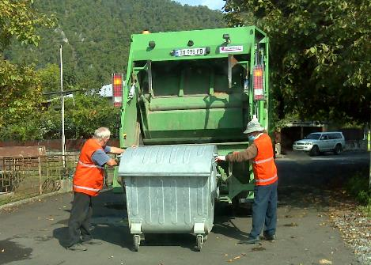 | 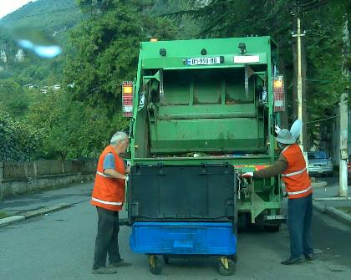
Metal containers due to their sturdiness can be fixed easier with their trunnions in the lifter arms. Their covers also open and close automatically during the emptying. | Collection crews must open the lids of plastic containers manually in order to ensure a gentle handling and keep the risk for damages low. The lids must also be closed manually after emptying.

- Container losses due to incidents of ignition of the content and resulting overheating or fires have significantly grown in number since the introduction of the plastic containers. The numbers vary between the municipalities and there seems to be also a difference in the occurrence between rural and urban areas. In less than a year the proportion of containers lost on such grounds must be seen somewhere in a range between 3-7 %, however. Plastic containers for obvious reasons are more at risk here. Positively noted is that till to date incidents of that sort have less often been observed in the more rural structures. The disadvantages plastic containers have in certain parts of the rural areas hence derive from the multiple reasons mentioned earlier rather than the danger of ignition.
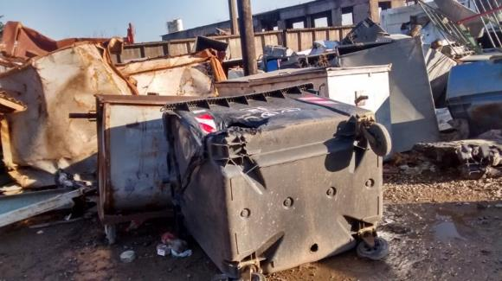 | 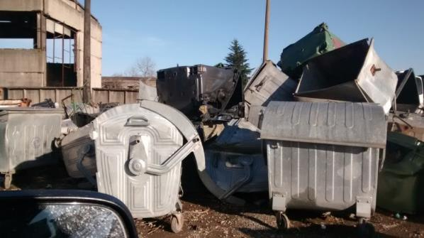
Impressions from a storgage place for damaged containers in Kutaisi, in both images new 1.1PlaC damaged by heat or fire can be spotted

Collection trucks
Although the container sites as a general rule are practically chosen, it has been noted that the time needed to empty containers (loading time) is about 50 % above that in countries like Germany. This is less a matter of the crew performance, which is actually quite satisfactory, but has its reasons in suboptimal technology and component design on the used collection trucks. Especially the lifter and compaction mechanism at the trucks is not optimal for an efficient collection. The need for multiple lifting and manually initiated compaction in the course of the loading operations wastes time. Moreover do the crews face unnecessary high burdens and physical stress to have containers emptied in a terrain that is difficult in itself.

Lifter system:
- The new collection trucks are models of the rear-end loader type, equipped with a lifting device that should suit for containers with a comb bar and/or trunnions to the left and the right of the container body.
The collection crews at present fix the containers via the trunnions at the truck’s lifter system. Fixing the trunnion in the lifting arms requires a precise work and alignment of the container. This is especially complicated on inclined ground where the container warps and trunnions are thus not equally positioned. Using the comb bar would make things much easier here. The container only must be positioned parallel and brought in contact to the lifter. The comb teeth on the lifter arm grab the container automatically once the lifting process is started.
All the newly supplied containers have the necessary comb structures for using this technique. However, a constructional mistake apparently exists at the current lifter system in that the lifter arms were affixed in an inappropriate position and their stroke length is too short. The mismatch resulting from this with the container’s comb bar prevents the waste service crews to make use of lifting with the comb technique, and therewith a much faster and easier collection process.
Both, the fact that lifting with the comb technique obviously doesn’t work on their trucks and that containers of different standards (with and without comb bar) and dimensions (e.g. 0.6 cbm) occasionally still exist, meanwhile triggered several municipalities to modify the lifting devices and therewith incapacitate them ultimately for lifting with the comb. The advantage of this modification is that the lifter arms can be adjusted in distance to match smaller container sizes.
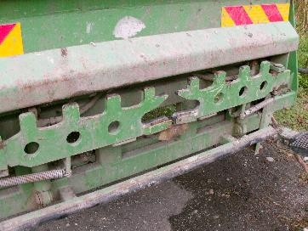 | 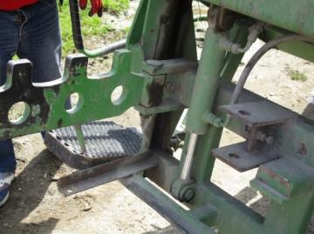
Lifter arms with comb teeth and slots for the trunnions. The comb bar could as well be used for lifting but a constructional mismatch prevents this on the current trucks | Some waste service companies meanwhile added a suspension (red arrow) to the trucks’ superstructure and this way incapacitated lifters finally to suit for the comb technique.

- The lifting speed at the current trucks resp. lifter type also appears to be relatively slow compared to other models and observations from practice. This as a matter of fact adds to the time losses.

- Additionally, when reaching the highest point the container lifted still shows quite a broad angle to the vertical line (repose angle) which means that the content does not drop out easily by the mere force of gravity. Loader crews hence must repeat the lifting or try to empty the container by means of shaking the lifter uncommonly often. This costs quite a lot of time and additional energy.
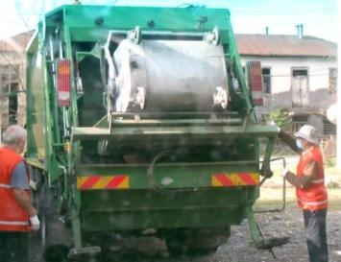 | 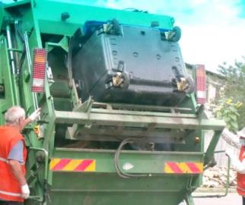
Containers at the highest point during lifting whilst the repose angle is likely below 40 degrees
Compaction mechanism:
- Collection trucks are usually equipped with a compaction mechanism to be able to use the full carrying capacity. All newly procured trucks have such a mechanism in the form of a pusher blade. As a general rule, such pusher blades can be activated for compressing the waste in the truck body while the vehicle is driving. Waiting time for the compaction during loading is minimized this way and the truck body again receptive when the truck arrives at the next loading point.
It appears as if it is not possible to make use of this procedure with the trucks currently in use. The loader crew instead must start the compaction manually after a container was emptied and with the truck retaining in a standstill position. To start moving drivers must wait until the compaction is finished. Oftentimes the compaction must be initiated between each container emptying which increases the waiting time and speaks for a rather weak technical design and low power configuration of the mechanism. The technology used for compaction in the present truck models obviously is not optimal.
Safety components
- Truck drivers can only insufficiently see the space behind their vehicle. Again and again serious accidents are being internationally observed hurting crew members but also uninvolved third parties during push back operations. A statistical analysis in Germany in 2008/09 showed that 20% of the accidents involving members of the collection crew and occurring during driving operations happened in conjunction with reversing [DGUV, Unfallkasse NRW]. Certain assistance systems on trucks are meanwhile introduced to increase safety when reversing. These systems range from warning signals to automatically stopping the vehicle.
The newly procured trucks are equipped with a sound signal that warns when drivers shift into reverse gear, a technique which doesn’t any longer correspond to state-of-the-art, however. Camera surveillance systems or a mechanism that automatically disrupts the traction of the trucks while crew members stand on the travel platform when reversing would be more effective.

Recommendations
The supply of the municipalities with new trucks and containers has enhanced significantly their capacities to provide waste services and collect properly the waste generated by residents and from small commercial units.
From the field investigations done can be concluded that the equipment supplies have generally been sufficient for ensuring that service for mixed municipal waste can nowadays be provided in an appropriate amount and intensity in those areas of the municipalities that produce the highest waste quantities and possess of the infrastructural prerequisites for an efficient collection process. Inefficiencies in very varying extent are however a danger and/or the natural consequence of the rather general distribution pattern applied for the equipment supplies (i.e. flat numbers and uniform types of trucks and containers) across municipalities of various size, and their different approaches to work with this equipment. It is an issue which must be thoroughly taken into consideration for future procurement rounds and in formulating the conditions and specifications for that.
As far as collection vehicles are concerned it definitely is worth to add trucks for the collection of mixed waste at this moment in moderate number and selected cases only. As a priority the substitution of trucks at a normal replacement rate should be ensured by such procurements. An acute shortage of trucks may exist in just a few cases at present, however, wherever service areas will be further extended and new services (such as for separate material collection) added, additional trucks are definitely required.
Especially for the separate material collection this may also involve the need to purchase vehicles that are different from the truck models for residual waste collection, e.g. skip loader vehicles. For the mountainous territories supplies of multipurpose, special all-terrain vehicles in well-justified cases and the adoption of the principle that these places be generally equipped with 4-WD trucks should be envisioned. Certain demand exists also for trucks or devices for container washing. Handling the costs for operating the trucks right now is a challenge though in all municipalities already. Improvements in collection efficiency are therefore essential and at least as much important as are single requests/wishes to purchase additional collection trucks.
Which kind of technical improvements and upgrades must be given special attention in the procurement of new resp. additional collection vehicles has been comprehensively described and discussed in chapter 4.2, points f-j above.
For further rounds of a centrally managed procurement of new or additional container units it is recommended that these be guided from the following aims and directions and take a focus on:
- Achieving a harmonization in the stock of containers municipalities use for collecting mixed waste.
Enabling municipalities to replace (their old-fashioned) containers of different types and dimensions and introduce containers of a uniform standard will also allow them to improve the collection efficiency in that a consistent basis for truck deployment and tour planning is created. Adjusting trucks and creating extra tours to deal with certain container specificities aren’t any longer necessary then. Which and how many containers are concerned must be established via an inventory, for that a corresponding registry method and tool has been developed and proposed (by the AMC) already.
- Ensuring the substitution of containers (resulting from wear, irreparable damages and losses) at a common replacement rate. For coarse orientation this replacement rate can be assumed with 15-20% per annum.
- Ensuring the availability of a sufficient amount of 1.1 round-cover metal containers. These should preferably be handed to and deployed in the remoter, more rural type areas and those (other) places in municipalities that are prone to misthrows and acts of vandalism.
- Supporting municipalities with the containers (numbers and types) needed for extending and improving the collection services in the not yet connected areas. This support should, however, be granted under the provision that the expansion follows transparent reasons (e.g. new road development) and that a sufficient efficiency of collection is ensured by planning the container distribution and collecting tours accordingly. It is not advisable to promote the increase of the stock and distribution density of containers in municipalities at the expense of a decline in collection efficiency (see the conclusions in a separate report on the pilot investigations).
- Creating and/or increasing the stock of containers serving separate material collection whereby special attention should be paid here on container models which are different from those containers used for the collection of mixed residual waste (i.e. specifically modified or suited for the purposes of separate material collections, e.g. igloos/bring banks, skip containers, containers with special feed hoppers, access flaps or locks).

Like in the previous round of procuring plastic waste containers (from the company ESE in Germany) it would be furthermore advisable that furnishing containers with a feature for unique identification be included in the tender specifications. Such feature would be extremely helpful in establishing registries and procedures for future inventory and monitoring of equipment.
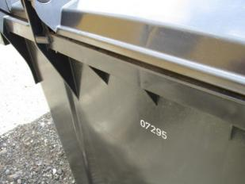 | A unique product ID such as the sequential number embossed in the plastic containers purchased from Germany in 2017 can provide a useful aid for inventories and monitoring
Ref. [1] Figures obtained upon specific inquiries via email response or document attachments or in personal interviews from the SWMCG

